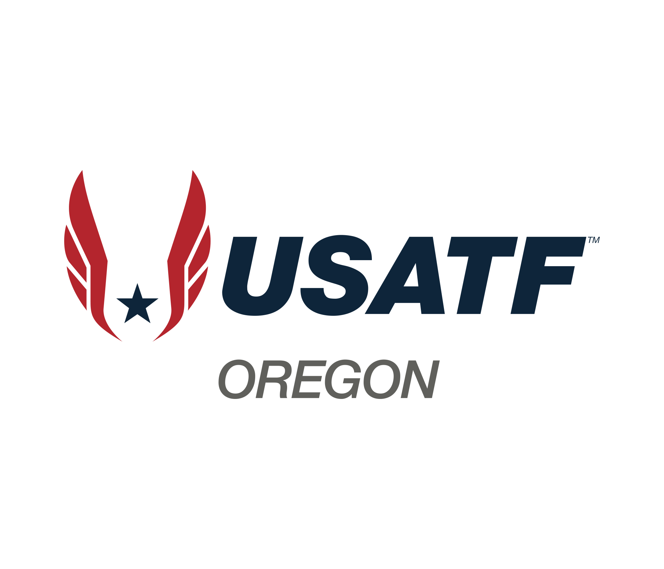
Board Meeting Minutes

February 1, 2026

Youth Chairs Election Meeting
The meeting began with Lynn Brown, USATF Oregon President, introducing the first youth meeting of 2026 and announcing the election of youth chairs. The candidates are La Kadron Ivery, Gabby Simdars, and Doug Burnett. Lynn invited each candidate to share their background and vision for the role, followed by a Q&A session. Doug was the elected winner of the Youth Chair position. The meeting also touched on administrative matters, including the need for clubs to complete the Youth Preference schedule and be 3-step compliant to be eligible to be listed on the Developmental schedule calendar.

