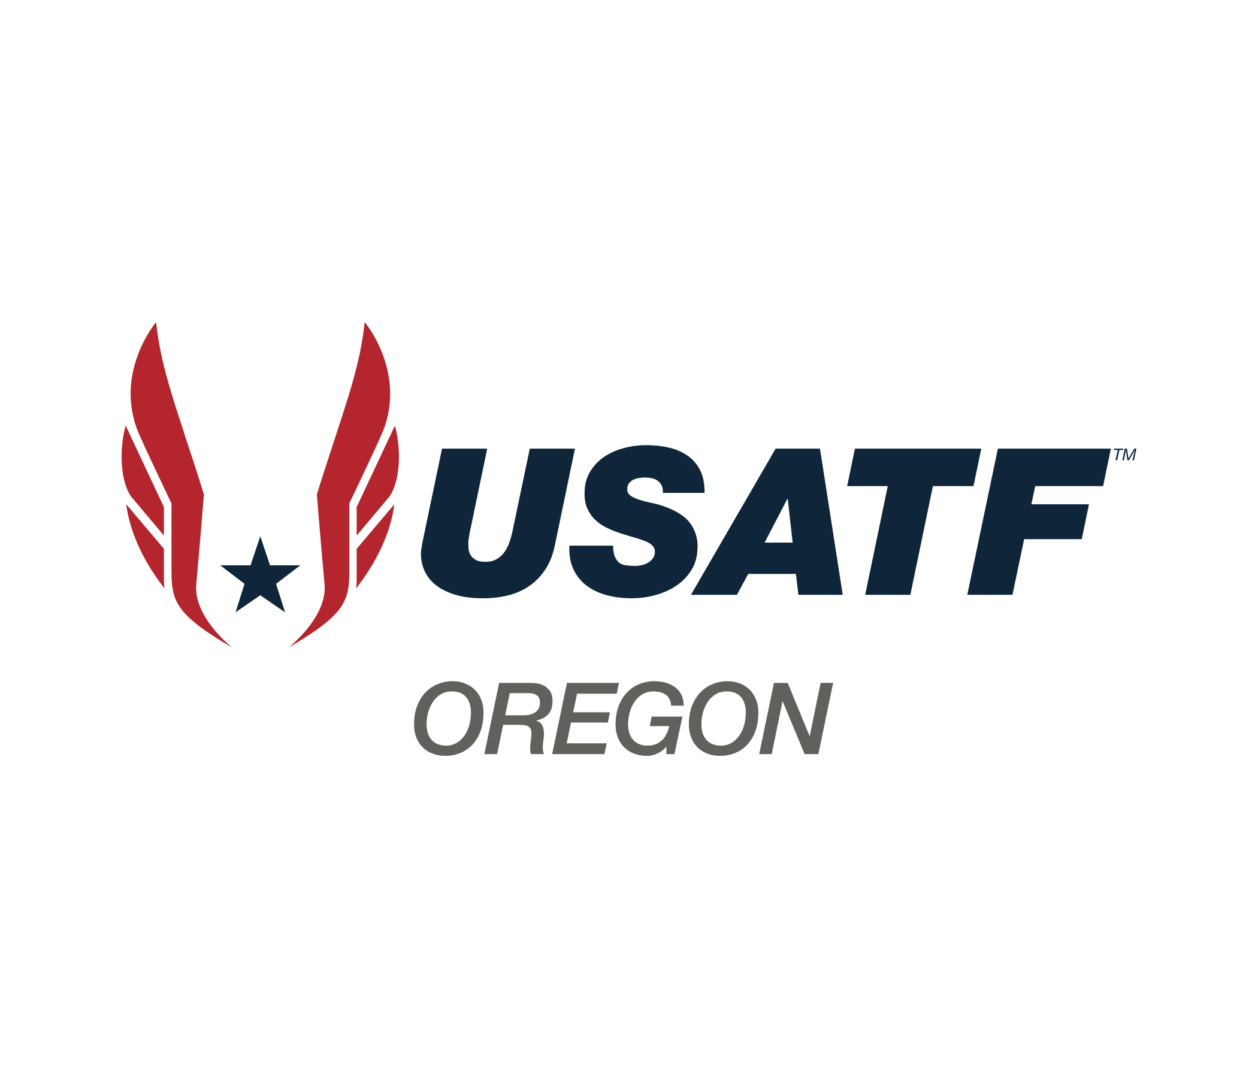

Board Meeting Minutes

October 20, 2024

7:00pm

Zoom:

<https://us02web.zoom.us/j/85700134560?pwd=TS9zY05maHBrWEhySnVYYmJrQVBTQT09>

1. Roll call of Board Members –
   1. Present: Phil Sutton, Billy Fields, Roger Hall, Tom Milbrooke, Carl Sniffen, Jerry Westfall, Susie Hammond, Carol McLatchie, Scott Phoenix, Matt Lydum, Marie VerMeer, Lynn Brown
   2. Excused: Debi Hanson, Gibby Reynolds
   3. Membership Observers: Amy Vetter, Mike Blackmore, Maureen Pollock, Fran Munkenbeck,
2. Approval of past Board Minutes – Tom made the motion to approve, Matt 2nd. Roger made the question about the potential addition of his name for attendance list. Minutes approved with correction.
3. Secretary Election – Amy Vetter and Susie Hammond both running for the position. Amy Vetter will be our new Secretary.
4. Committee Reports changes – In January, we will return to presenting committee reports during the meeting. Please continue to send a copy to the Secretary to have your information included in the monthly minutes.
5. 2026 Club National Cross Country Championships – We will table this discussion until our next Competition Committee Meeting on November 10, 2024.
6. Communications – Please be sure to respond to all emails within 48 hours.
7. Officials’ renewal – Scott will be hosting Zoom review for Officials in November to prepare for renewal of their Official Certification. Master/National Review Meeting November 12th. Basic Review will be November 5 & 6th. Gibby and Scott are currently working on a plan to provide Officials with additional payment options.
8. Updating Delegate Criteria Point Sheets – If you have suggestions of things that should be added to the Delegate Criteria points, please email Roger and Lynn. We will be working on updating this information by January 2025 to share at the January Board Meeting. Those interested in being a delegate (possibly virtual) for the 2025 Annual Meeting should start working on accumulating their points.

New Business – Scott shared an update regarding the AED bill that Fran M. has been working on. “I thank the Oregon USATF for being willing to put their logo on the educational flyer for the SmartHeart bill. Other organizations have agreed to add their logo and include Nike(a young person just got resuscitated on their campus), Oregon American College of Cardiology, PeaceHealth, Mckenzie Willamette hospital, Oregon Society of Emergency Physicians, Lane County Medical Society. Others are pending.

At this point the bill will be submitted the first day of the legislative session to give the best chance of it going through. A lot of bills get put forward and the sooner a bill is put forward the better chance it has to pass. Oregon State Representative Dacia Grayber will sponsor the bill and her background is being a firefighter/paramedic.

A grant is being worked on to get AED boxes for outside sport areas locally in the Eugene area. The boxes open with a code so devices are not stolen but these boxes are spendy and not sure we will get the grant. For these boxes if someone does not know the code, then they call 911 and they are given the code.

The NFL got for schools and I think nonprofits that work in kid sports(I need to check on the latter) a 20-60% reduction in cost of AEDs(they negotiated this with the AED companies- they are not giving the money directly) and the discount also holds for parts like pads and batteries. The NFL just announced this but not sure when it is going forward.

There is also a Federal bill that will supplement the state bill and Senator Merkely is co-sponsoring it. It passed the House and it is going to the Senate for which Merkely is sponsoring. We will see.

That is the update. Thank you for your help. Fran Munkenbeck”

Lynn Adjourned the meeting by acclamation.

Respectfully submitted by Lynn Brown, Interim Secretary.

**USATF OREGON ASSOCIATION RACE WALK COMMITTEE**

**OCTOBER 2024 COMMITTEE REPORT – 10/19/2024**

**Completed Activities:**

* Participated in the 2024 USATF Oregon Annual Meeting: provided a recap of 2024, tentative dates for 2025, a focus on increasing Youth race walkers and training for race walk officials. Congratulations to our 2024 Race Walker of the Year winners: Stephanie Casey (Open) and Karla Snyder (Masters). A 2024 Contributor of the Year award was presented to Carmen Jackinsky. Congratulations to our recipients!
* Held the Northwest Regional 10K Race Walk Championship on September 22. There were 4 entries, 3 finishers. Many thanks to our officials (Jerry Westfall, Pat and Dan Swehosky, Maureen Robeson, Scott Phoenix, Marie VerMeer) and the volunteers who helped make the event go so smoothly! Also a special shout out to the Head Track Coach at Rex Putnam (David Lemen) who stood in as the Facility Coodinator in Roger’s absence. The weather was absolutely beautiful; in fact, just a bit warm towards the end of the race. We’ll do some additional targeted marketing for the event next year to hopefully grow the numbers.
* Provided updated 2024 event and results information and content to Phil Sutton for refreshing the USATF Oregon Race Walk web page, including tentative event dates for 2025 competitions.

**In Process/Continuing/Upcoming Activities**

* Marie and Roger are continuing to define an in-person Race Walk officials clinic that would be part classroom, part “live” experience officiating on the track. This likely will be held in the fall or winter (align with recertification). Another Association does a 1 day event that includes clinics for athletes and officials and an 800 and 1500M event for athletes to test their skills and officials to practice so may try to model something similar for Oregon.
* Continue to provide updated event information (results, event times, etc.) to Phil Sutton for addition to the Race Walk Page on the USATF Oregon website.
* Hold monthly one-hour Race Walk Judging/Officiating reviews via Zoom – we’ll start these again in January. Clinic was designed as a basic overview and review and Q&A session.
* Collaborate with Scott Phoenix on organization for Race Walk Judge/Official certification and recertification activities for 2025 – 2028 Olympiad.

**Other Items:**

* None to report.

Respectfully submitted,

Marie VerMeer

USATF Oregon Race Walk Chair

Oregon Association USA Track & Field

Submitted by Matt Lydum

October 20, 2024

Level 1

new hybrid (asynchronous/synchronous) format for the certificate

*Applied for Oregon Association In-person Events Level 1 at Canby HS Feb 15-16, 2025 (Presidents Day).*

USATF Level 1 – In-person “events” December 14-15, 2024 Houston, TX

USATF Level 3 – Endurance December 1-4, 2024 Bradenton, FL

USATF Level 3 – Sprints/Hurdles/Relays December 1-4, 2024 Bradenton, FL

**Certification Chair Report - Oct. 20, 2024**

**Recertification**

This began Oct. 1 with ability to take the new rules reviews. This was done with the hope that certification chairs would not have too much to do within a shorter period of time before Dec. 31, the date USATF would like officials to complete the process. To date, not that many Oregon officials have submitted results for either the Basic or the Advanced Review. November 1 is the official beginning of recertification. I will have at least three Zooms to assist officials in taking the necessary reviews - Nov. 5 & 6 for the Basic Review (voluntary attendance) and Nov. 12 for the National & Master (mandatory attendance). Those who cannot attend the Nov. 12 one will have to make arrangements with me for a make-up session.

**Certification Chairs Asked to Help Test the Reviews**

I was one of the individuals tasked with taking a review to see what problems there were with it and to suggest solutions. My review was the one for Race Walking.

I sent multiple emails back and forth with Richard Boyd, NOC Rules Chair, and others in an attempt to clean up the Basic Review. There were incorrect answers and rules references and with all the give and take, the review was improved.

**Applications for National Meets**

I contacted many Oregon officials about submitting applications for National Championships and 57 ended up applying for Major Championships. I wrote evaluations on all of them.

**Awards**

I submitted names for national awards, collaborating with Phil Sutton on a couple. Oregon was the only association in Area 1 (out of 11) to have nominations for all national awards. We have finalists for three of the seven awards.

**New Trainings**

I am making preparations for a new season of Zooms and also laying groundwork for a run at the NOC Training Chair position. If I am elected to it, I will continue as Oregon’s Certification Chair. I also will work in conjunction with the Oregon Track Club for scheduling in-person clinics.

**Association Track and Field Championship 2025**

I am working with Newberg HS to see about the feasibility of having our championships at these two locations.

**Basic Review**

**Ques. 8**   Is the parenthetical phrase (which happens to be incomplete as it is) supposed to be included?

(rule book uses he)  What does that mean?

**Ques. 10**  The word *in* is missing the i

An attempt n the...

Also, choice d is indented too far.

**Ques. 12**

Choice A should read Enters from the front of the circle to make an attempt.  As is, it's saying that the attempt must be made from the front of the circle.

**Ques. 13**

Rephrase - Competitor A, who had declared for the high jump, arrives late, escorted to the venue by the call room clerk.

The competition just began prior to the late athlete's late arrival.

**Ques. 24 & 25**

You include Marshal Best Practices.  Aside from giving away the answer by including it, you are making reference to a document this review is not supposed to be based upon.  It is supposed to be based solely upon the 2024 rule book.

**Ques. 28**

Word choice -

d. The reace director states the distances in the advertisement literature to the athletes.

**Ques. 49**

A competitor shall not be disqualified if he or she, in all races run in lanes, touches...

**Quest. 51**

When more than eight athletes are competing in a field event, it is required for an athlete to have a legal mark in the...

**Ques. 66**

What answer are you expecting to be provided?  The inside of the rim is legal to touch but the top of the rim is not.  Do you mean the inside top of the rim?

**USATF Oregon LDR Committee Report – October 2024**

This month, we successfully developed a new partnership with the **Haulin’ Aspen Trail Marathon and Half Marathon**. This event will be a key addition to our schedule, providing new opportunities for our athletes to participate in trail running events.

We’ve also initiated discussions with the **Eugene Marathon** about hosting the **2025 USATF Oregon Association Full and Half Marathon Championships**, which would be a great platform for our athletes next year.

In addition, we’ve continued our collaboration with **Red Lizard**, which remains strong. Their new Stumptown XC chair, **Steve Short**, has been instrumental in helping us prepare for the **USATF Oregon State Championship Event**. This event will take place at **Pier Park** on **November 9th**, and we’re excited to see it come together.

**Susie Hammond**  
USATF Oregon Association LDR Chair

**USATF Oregon Youth Chair Report (October 2024)**

By Billy Fields

November 15, 2024

On November 9, 2024, we had the USATF Oregon XC JO Championship at Western Oregon University—Ash Creek Preserve.  Of the three years I have been involved with this XC Championship, I think this was the best one for me.  The rain held off.  The course was not too muddy, though plenty of mole-like holes were everywhere.  I was told they were bee holes.

Leading the 248 participants with the gator and hyping up the on-lookers was phenomenal.  I really enjoyed this year.

Also, the USATF Meet Management Team and Officials did a wonderful job.  Some changes we made from last year made this year much better.  Thank you all.

We are still in the process of re-creating a better SOP for Region 13 meets. To be continued.

The building of the youth committee is still ongoing.  I was able to talk directly to Bobby and he let me know more about the situation.  It does not look like Gail will do it.  I will continue to work on building that committee.

I enjoyed the action plan I was on for the XC meet.  It was great to have direct training and input.  I have already started the plan for the Track Association championship.

I am also engaging in more reading of the materials that have been provided.  The learning curve continues.

Respectfully Reported,

Billy Fields

USATF Oregon

Youth Chair