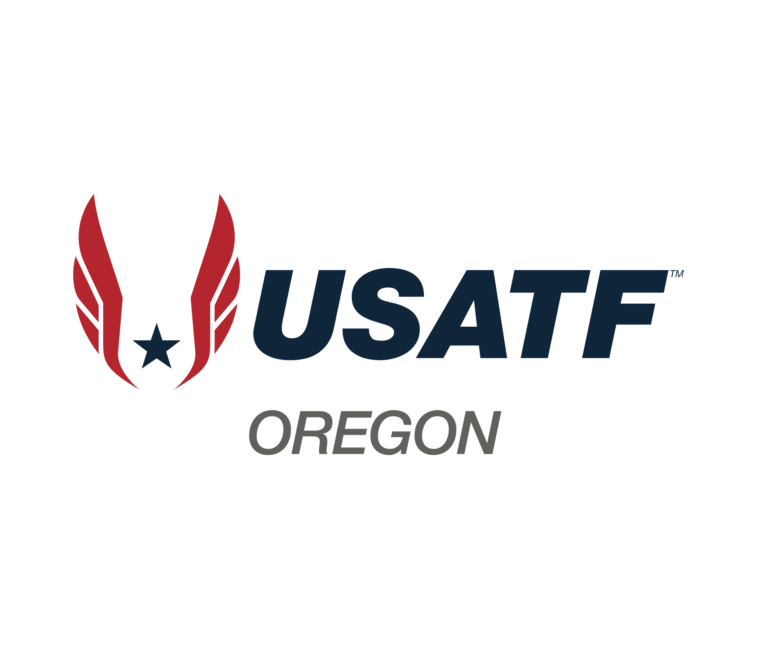

Board Meeting Minutes

April 27, 2025

1. Roll call
   1. Present: Lynn Brown, Gibby Reynolds, Amy Vetter, Jerry Westfall, Roger Hall, Pete Castro, Marie VerMeer, Tom Millbrooke, Scott Phoenix, Carl Sniffen, Phil Sutton,

Peter Cobin, Debi Hanson,

* 1. Excused: Rick Stucky (traveling)
  2. Absent: Matt Lydum, Carol McLatchie
  3. Membership Observers: Ivan Faulhaber

1. Approval of March minutes: 7:07pm by Scott, 2nd by Pete, Approved - All but 1
2. Committee Reports-

Race Walk (Marie/Roger) May 18th at Rex Putnam the association racewalk meets. Marie and Roger have been officiating different races in the area. 4 officials attended the online racewalk class. Amy and Roger also officiated the Corban meet last weekend, we have the Hayward Classic next.

Membership (Lynn) 1952 members, 612 valid clubs in the association.

Certifications (Scott) Phil had provided a list of people interested in officiating and that had given us 28 new officials. It’s a work in progress, but there is interest, mostly older, some not as old, (yay).

Officials (Gibby) 6 people attended the Starters Basics class, 3 in person, 3 on-line. 15 people have been certified for the HS only certification.

Sanctions (Debi) Feels like there are a lot more this year than in the past. We should see some income from sanctions this year.

Safe Sport (Carl) If you were the parent of SafeSport, you’d not say it’s going well - there’s a scandal in there. Nothing that affects us. In May Carl will meet with Rick and Lynn so we will be set for JO’s.

Para Athletics (Phil) None

Coaches ed. (Tom/Matt) Go to the National link to see what classes

Treasury (Pete) General - $105,163.67 Officials - $6,570.06 Savings - $20,990.60

Masters (Peter) Portland Meet will not be the Regional Master’s Meet. We will be discussing that later.

Youth (Rick) None (traveling)

Open (open) None

LDR (open) None

1. Youth XC dates: November 9th Ash Creek is not available. National is allowing us to move to another weekend (15-16th) if venue is available. Regionals is November 22nd. We have 11/8-9 or 11/15-16 to work with, Jerry is working on it.
2. Current open board positions: Ivan Faulhaber has submitted a resume, and we are going to apply it toward the open “Open” position. Grew up in Eugene, passion for T&F, grew up participating and watching it. Retained his affinity for T&F, feels it is pure and simple. He wants to help promote the sport. Been coming to USATF meetings/events to feel it out. He’s a Baseball/Football coach for David Douglas HS so has some commitments but wants to be involved.

(Lynn) Ivan has been attending youth meetings and has worked with Scott to get certified as an official with aspirations to officiate the Olympics in LA.

Caleb Ries has applied for LDR but we have no resume.

1. Election update: This election year it’s Gibby, Amy, and Pete. So far no one has submitted applications for those positions.
2. Eugene Marathon: Phil and Scott have been hosting a table down at the Eugene Marathon. Lynn went down today to hand out medals but there was a database issue, and they were not able to capture the winners, so they were not able to. They will mail the medals out when they are finalized. Haul-n-Aspen is coming up this summer, so they will mark the USATF members participating so this doesn’t happen again. The USATF table at the hotel over the weekend was manned but there were 12,000 athletes entered so they need to be identified as entered in the USATF Championship in the database to come up with those results. Haul-n-Aspen will be smaller than Eugene Marathon.
3. Masters Meet: Peter, Roger, and Lynn had been working with Portland Masters to try to combine their meet with our Regional Meet. But we couldn’t guarantee that it was going to be a great meet and to have our USATF name on it, it needs to be. This was discussed with George Matthews, and he understands. On the August 23rd date that Roger and crew came up with all the regular venues are booked. Marie points out that August 23rd is the Hood to Coast date. A 2025 Masters Championship is a requirement for our certification, but since the Eugene Marathon had a Master’s division, we will still be OK if we do not host a Regional Championship meet this year. Lynn is requesting a vote of the board to table the Masters Championship for 2025 and work on a good Regional Meet for May or June 2026. Phil 2nd’s it, Gibby was opposed. We can’t use the Hayward Classic as our meet because they do not run hurdle events or weighted throws which are required. So, we will start looking for venues for 2026 where we can have a successful meet; we can add open divisions to it and have a great meet. (Lynn) We will NOT host a Master’s Meet for 2025 but will move forward to 2026, she will contact George so he can get things going in Washington.
4. New business: Why do we not have the “All Comer Meets” on our youth schedule? (Answer) All Comer meets, and most developmental meets do not host all the events that are contested in championships. (Roger) Back when Dion was the youth chair, we left it up to the clubs of what they hosted for developmental meets, to get it done in 1 day. Since it was all younger kids, they didn’t have to host pole vault and some of the other events that are not for beginners. We leave it up to the individual clubs as to what they wanted to contest.

(Phil) - We need to publish, as best we can, whether we are contacted or not - all (or as many of) the All-Comer’s Meets as possible! We need to get these youngest kids interested in our sport and this is the way. A comprehensive list of these meets from all the parks and recreation departments, OTC, Tualatin Hills, Salem, Grant Park. OTC has 2 divisions for their All-Comers Meets: 12 & U and 13 to 105. To get them on our website is an issue since we can’t change the website configuration, Phil will figure it out.

We still have no location for the USATF National JO’s. Since North Carolina pulled their offer, we have been struggling. 4/4/25 National announced that within 2 weeks they would be announcing the new location... that date passed and there is still nothing. National told NC that they couldn’t make money on apparel, which was the only way they were going to make any money, so they pulled out. It is not public which the other 3 locations are that bid, but MC has confirmed that they are not 1 of them.

We could offer something, like a “West Coast Invite” to help our Oregon athletes, and some CA and others. We tried it a few years ago but the entry standards were so high, it was truly an elite meet, not for everyone. Something like the “Track City Invitational” was, we will be a great option for athletes that want to be closer to home. Then we don’t have to wait for National to tell us what to do.

AAU is going to overtake USATF in 3-5 years.

There was an email blast ready to go to encourage membership to contact the National Office about this National JO mess, we have been holding it to wait to see if the Monday announcement comes. Lynn asked Phil to send the blast on Tuesday. They are a week overdue of their last promise.

Gibby - needs access to the stripe accounts. Roger or Jerry need.

Meeting adjourned: 8:32pm