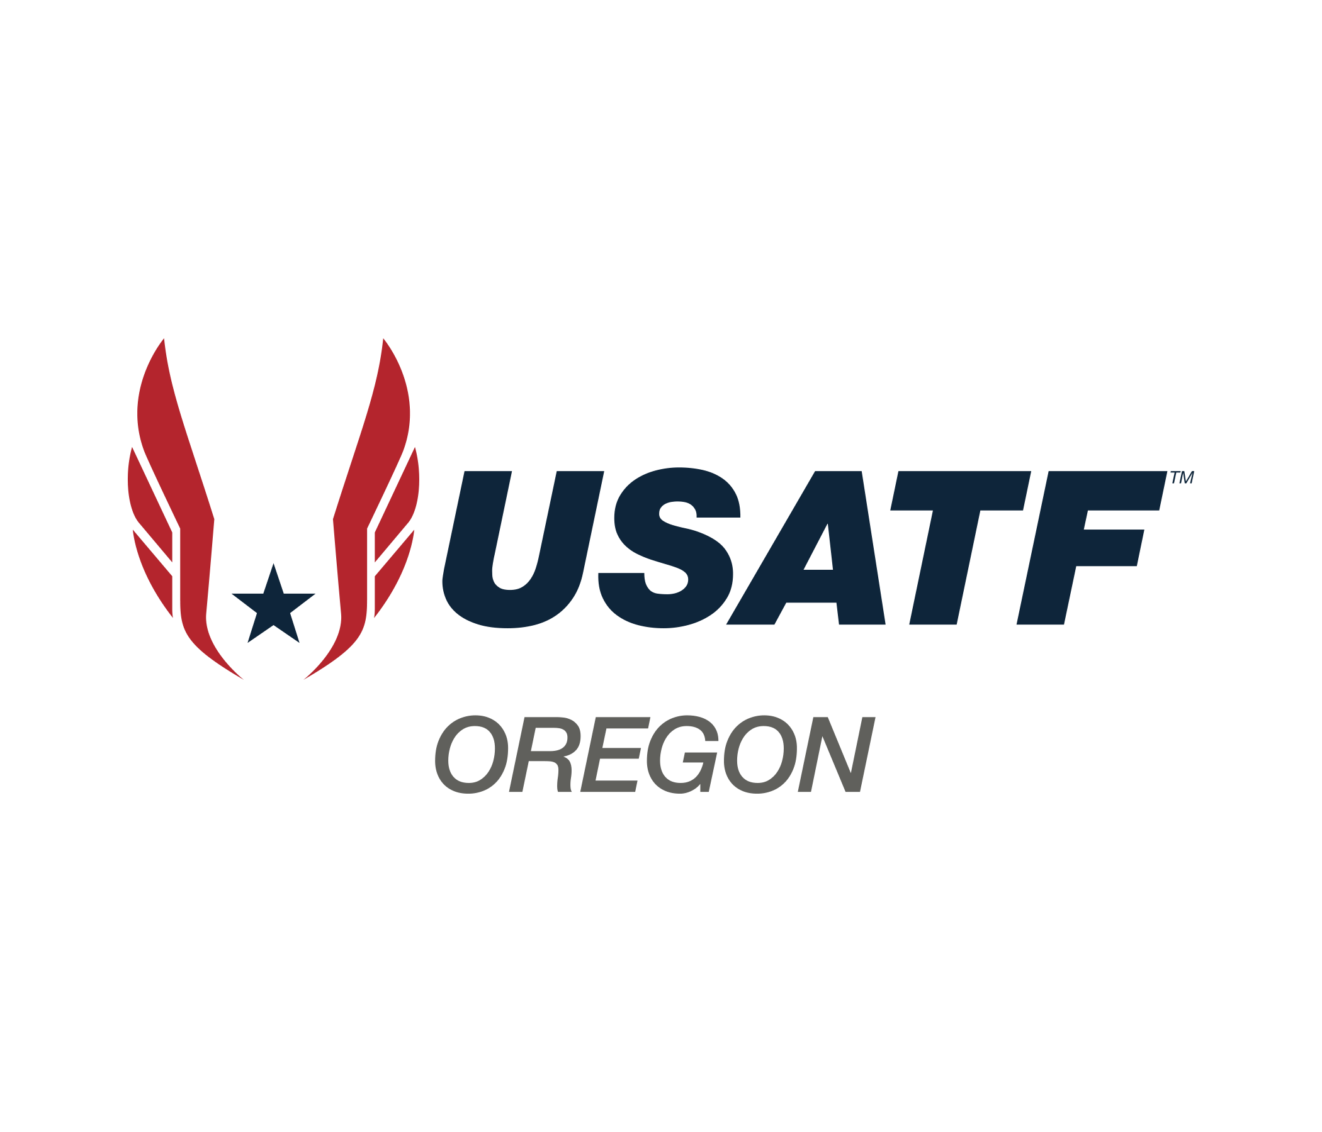
Board Meeting Agenda
April 19, 2026
7:00pm

Zoom:
https://us02web.zoom.us/j/89684736636?pwd=6CawdCzV21EBUTO5BBNqpX35zmRyXF.1

- Roll call
  - Present: Ivan Faulhaber, Phil Sutton, Gibby Reynolds, Marie VerMeer, Mike Blackmore, Carl Sniffen, Tom Milbrook, Lynn Brown, Debi Hanson
  - Excused: Amy Vetter, Pete Castro, Matt Lydum, Scott Phoenix
  - Membership Observers: Eric Hartmann, Roger Hall

- Approval of minutes: Carl made a motion to approve with corrections. Mike 2nd. Minutes approved.
- Approval of agenda: Phil made a motion to approve. Carl 2nd.

- Committee Reports-

- Coaches ed. (Tom/Matt)
- Collaboration (Phil) – Has heard back from Boring Marathon 10k. The Boring Marathon Board has agreed to also host a Youth 5k. Phil will draft an MOU. Stumptown Racing is considering hosting our Youth JO championship in November. Meeting is scheduled for Tuesday to discuss Revenue sharing.
- Communications (Phil) – WIX is finally set up for our website. The content management website is very intuitive, but AI help is very intrusive but has been disabled.
- LDR (open)
- Masters/Open (Ivan) There is a bigger push to get in contact with Springfield HS. Has reached out to Lane CC. Reached out to Sheldon. Will reach out to AD in 4Js to see what is available. Looking for a venue for 8/8-9
- Membership (Lynn) – There are currently 2092 active members. 68 approved clubs and 14 clubs that need corrections to be approved.
- MUT (Mike) Will continue to work with Ivan to locate a venue. McKenzie HS might be an option.
- Officials (Gibby) We have some replacement parts for a laser on order. Looking to have equipment repair after major winds this week.
- Certifications (Scott) - Excused

- Para Athletics (Phil) – National Para Olympic recently hosted a meeting for all Association that have Para Athletics. If we want athletes to participate in Para, they have to be certified with their disability in order to be eligible to compete. Officials must use 3 rule books.
- Race Walk (Marie) – Has had a couple of RW basics training. Updated 5k content for May 17th. Registration is open and will close on May 15th. Currently 2 registrants. Peacock is currently showing RW Championships. Competitors from Oregon or that have started in Oregon were able to compete
- Safe Sport (Carl) – Nothing new to report. There is a lot of excitement and energy in protecting athletes. National USATF Safe Sport has made some changes in their department. The new contact person is Liz. The new club portal is open.
- Sanctions (Debi) – Nothing to report currently.
- Treasury (Pete) – Excused - Account balances provided.
- Youth (Doug) - Absent

- Delegate Subsidy Request – Tabled until May.

- Oregon Annual Meeting – September 20, 2026, Need a location. OSAA can host up to 50 people, we can consider this as a location. Elections for 2026 include: President and 2nd Vice Committee chairs shall be elected every other year (sport committees during even-numbered years, administrative committees during odd-numbered years);

- Chair Committees – Let’s work on building committees for all Board Members to make sure that someone else knows how to do your position.

- Rule Books – Lynn has 2026 Rule Books and will bring them to the May meeting

- New business –

  - Committee Chairs – Gibby missed the meeting in October that created a position for the Certification Chair.
    - Not sure that this position should be separated from the Officials’ Committee
    - Proposal is to keep the Certification Chair under the Officials’ Committee
C The vote was that his position be maintained in the Official’s Committee.
  - Monthly Financial Reports – Will we start receiving monthly reports.
    - Executive Committee receives a monthly report.
    - The Treasurer Report includes monthly balances.
    - Phil request that the monthly report be sent to all Board Members.
      - Lynn will follow up with Pete about this request.
  - Can we have a breakdown of how income is reported and explain how the line items are reported. Budget walk thru as an agenda item. Request questions in advance.

Lynn adjourned the meeting by acclimation.

Respectfully submitted by Lynn Brown, USATF Oregon President.

